**PER-TDBG Rev A0.1_0_0**

**Jumper and Connector Setting**

**User Manual**

**Block Diagram**



**Location of Connectors and Jumpers**

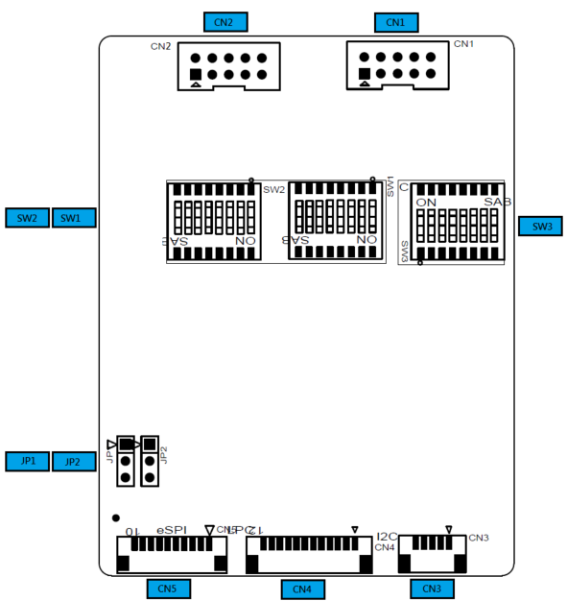

**List of Jumpers**

Jumpers allow users to manually customize system configurations to their suitable application needs.

**The following chart consist the list of each jumper function:**

|  |  |
| --- | --- |
| **Label** | **Function** |
| JP1 | LPC & eSPI Selection |
| JP2 | 82/83 & 80/81 Port Selection |

**(JP1)LPC & eSPI Selection Jumper**

|  |  |
| --- | --- |
| Y1-2  LPC (1-2) | Y2-3  eSPI (2-3) (Default) |

**(JP2)82/83 & 80/81 Port Selection Jumper**

|  |  |
| --- | --- |
| Y1-2  82/83 Port (1-2) | Y2-3  80/81 Port (2-3) (Default) |

|  |  |
| --- | --- |
|  |  |

**List of Connectors**

Connectors on board access link to external devices such as hard disk drives, a keyboard.

|  |  |
| --- | --- |
| **Label** | **Function** |
| CN2 | 8 bits GPIO(0~7) |
| CN1 | 8 bits GPIO(8~15) |
| CN3 | SMBus/I2C Port |
| CN4 | LPC Debug and SMBus/I2C Port |
| CN5 | eSPI Debug Port |

**(CN2) 8bits GPIO(0~7)**

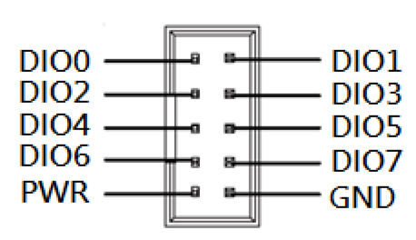

| **Pin** | **Pin Name** | **Signal Type** | **Signal level** |
| --- | --- | --- | --- |
| **1** | GPIO0 | I/O | +5V |
| **2** | GPIO1 | I/O | +5V |
| **3** | GPIO2 | I/O | +5V |
| **4** | GPIO3 | I/O | +5V |
| **5** | GPIO4 | I/O | +5V |
| **6** | GPIO5 | I/O | +5V |
| **7** | GPIO6 | I/O | +5V |
| **8** | GPIO7 | I/O | +5V |
| **9** | +5V | PWR | +5V |
| **10** | GND | GND |  |

**(CN1) 8bits GPIO(8~15)**

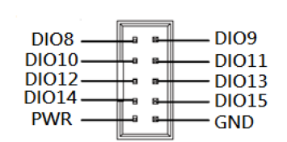

| **Pin** | **Pin Name** | **Signal Type** | **Signal level** |
| --- | --- | --- | --- |
| **1** | GPIO8 | I/O | +5V |
| **2** | GPIO9 | I/O | +5V |
| **3** | GPIO10 | I/O | +5V |
| **4** | GPIO11 | I/O | +5V |
| **5** | GPIO12 | I/O | +5V |
| **6** | GPIO13 | I/O | +5V |
| **7** | GPIO14 | I/O | +5V |
| **8** | GPIO15 | I/O | +5V |
| **9** | +5V | PWR | +5V |
| **10** | GND | GND |  |

**(CN3) SMBus/I2C Port**

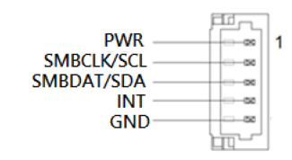

|  |  |  |  |
| --- | --- | --- | --- |
| **Pin** | **Pin Name** | **Signal Type** | **Signal level** |
| 1 | +3.3V | PWR | +3.3V |
| 2 | SMBCLK/SCL | IN | +3.3V |
| 3 | SMBDAT/SDA | I/O | +3.3V |
| 4 | INT | IN | +3.3V |
| 5 | GND | GND |  |

**(CN4) LPC Debug and SMBus/I2C Port**

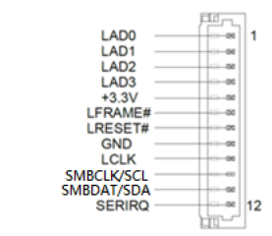

|  |  |  |  |
| --- | --- | --- | --- |
| **Pin** | **Pin Name** | **Signal Type** | **Signal level** |
| 1 | LAD0 | I/O | +3.3V |
| 2 | LAD1 | I/O | +3.3V |
| 3 | LAD2 | I/O | +3.3V |
| 4 | LAD3 | I/O | +3.3V |
| 5 | +3.3V | PWR | +3.3V |
| 6 | LFRAME# | IN | +3.3V |
| 7 | LRESET# | IN | +3.3V |
| 8 | GND | GND |  |
| 9 | LCLK | IN | +3.3V |
| 10 | SMBCLK/SCL | IN | +3.3V |
| 11 | SMBDAT/SDA | I/O | +3.3V |
| 12 | SERIRQ | IN | +3.3V |

**(CN5) eSPI Debug Port**

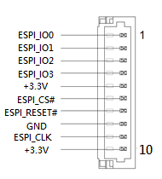

|  |  |  |  |
| --- | --- | --- | --- |
| Pin | Pin Name | Signal Type | Signal level |
| 1 | ESPI_IO0 | I/O | +1.8V |
| 2 | ESPI_IO1 | I/O | +1.8V |
| 3 | ESPI_IO2 | I/O | +1.8V |
| 4 | ESPI_IO3 | I/O | +1.8V |
| 5 | +3.3V | PWR | +3.3V |
| 6 | ESPI_CS# | IN | +1.8V |
| 7 | ESPI_RESET# | IN | +1.8V |
| 8 | GND | GND |  |
| 9 | ESPI_CLK | IN | +1.8V |
| 10 | +3.3V | PWR | +3.3V |